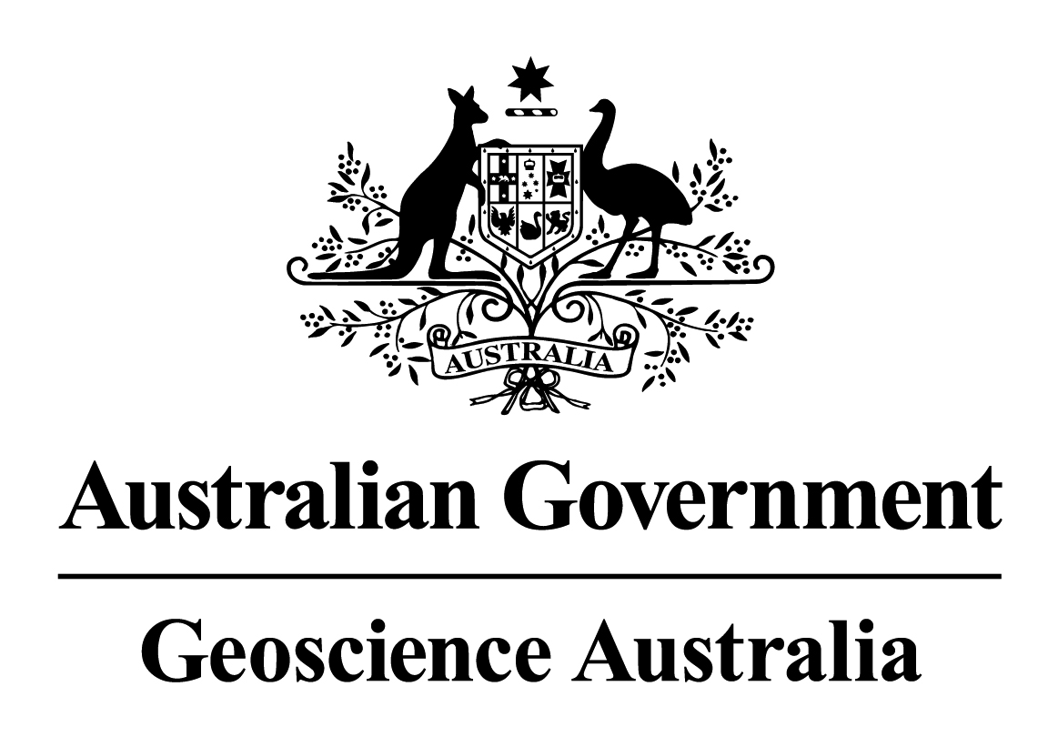
Merit Advancement Application
Level Advancement

Applicant’s Name: Jane Sexton

The Certified Agreement 2005-08 has this to say about Level Advancement:
- Employees must have an Individual Work Plan in place and have had a formal performance assessment before they may be considered for merit advancement (clause 64.8)
- The six Performance Categories – Achievement of Results/Outputs, Leadership, Management, Learning and Development, Client Interaction, and Corporate Contribution – shall be used in assessing employee performance, and are the criteria for advancement applications (clauses 63.7 and 64.12)
- Employees must indicate in their application which, if any, of the 19 performance indicators under the six criteria do not apply to their current role and responsibilities and which should be weighted more heavily as a result (agreed at the time of preparation of the Individual Work Plan) (clause 64.13)
- Employees must demonstrate sustained high performance at their current Level which means, in effect, that their current performance against work responsibilities and work complexity are commensurate with the description of work at the higher Level and their overall contribution is assessed as High Performance (clause 64.6)
- The Assessment Panel must be satisfied that the employee’s performance is at least Effective against each of the performance categories at the standard expected at the higher Level (clause 63.16).

Role and Main Responsibilities for the sustained period (2-3 years for Band 3 employees; 1-2 years for Band 1 and 2 employees) as described in your Individual Work Plan
Jan 09 – present: Project Leader for the Natural Hazard Impacts Project
- Responsible for guiding, developing and integrating project activities to ensure goals and outputs are met in accordance with the GEMD business plan and the GEMD IM plan,
- Provide scientific leadership particularly with respect to modelling and in particular emerging modelling needs,
- Responsible for the identification and tracking of budget and resource needs for the Natural Hazard Impacts Project and “day to day” maintenance of the project,
- Support Whole-of-Government approaches to natural hazard mitigation and disaster risk reduction in Australia and in the Asia-Pacific region,
- Develop and maintain relations with AGD, State Governments and AusAID, and
- Develop and maintain staff performance and development.

Nov 05 – Dec 08: Computational Modeller, Project Manager and Tsunami Risk Modelling Activity Leader
- Lead and manage the tsunami activity to ensure the delivery of project outputs,
- Liaise with State emergency managers (such as FESA, EMQ, NSW DECC and SES) to deliver desired products for emergency management purposes,
- Contribute to the strategic direction of the Project,
- Contribute to inundation and impact forecasting for the Australian Tsunami Warning System (ATWS),
- Liaise with other agencies in order to foster a collaborative approach to hazard and risk modelling and present work publicly, and
- Contribute to the development of software for computational fluid mechanics and inundation modelling.

Notes about Referees:
- Referees must be familiar with your work.
- If you have people management responsibilities, include as a referee the name of at least one of the people you manage.
- As part of the assessment process the panel may contact nominated referees and/or, at its discretion, others who are familiar with your work.
- Provide your referees with a copy of your application.
- Your application must include a report from your Nominated Manager. If you choose to use another referee, in addition to your Nominated Manager, you should indicate the reason for this on the referee form.

Applicant's Signature: |  | Date: | / /

Current Role and Main Responsibilities
Indicate if any of the performance indicators listed under the six performance categories do not apply to your current role and responsibilities, and any which you feel should be weighted more heavily as a result.
Your Nominated Manager needs to verify this (see below).

CRITERIA AND PERFORMANCE INDICATORS | Applies in current role | Needs to be weighted more heavily in current role
- Achievement of Results/Outputs
Contribution to team achievements | Yes | Yes
Record of achievement of results/outputs of value to GA project/work area/clients | Yes | Yes
- Leadership
Strategic perspective and contribution | Yes | Yes
Leadership in specialist area
Leadership of people | Yes | Yes
- Management
Managing self | Yes
Managing others | Yes | Yes
Management of project/work area/activity | Yes | Yes
Communication, liaison, negotiation and influencing skills | Yes | Yes
- Client interaction
Identifying client needs | Yes | Yes
Meeting client needs | Yes | Yes
Developing new ventures/projects/products | Yes
- Corporate contribution
Corporate awareness | Yes
Involvement GA/RET/APS/professional arena activities | Yes
Sharing expertise | Yes
Corporate information management
- Learning and Development
Development of Professional/Technical skills, knowledge, expertise | Yes
Development of self in line with GA key work values (Leadership, Management, Client Interaction, Corporate Contribution) | Yes
Development of others | Yes

Nominated Manager’s Signature: |  | Date: | / /

CLAIMS FOR LEVEL ADVANCEMENT
[Note: Size limit on the Claims part of your application is 3 pages in total]
PART 1 – SUMMARY OF CLAIMS
Provide a summary statement indicating why you consider the work you have been undertaking for a sustained period (2-3 years for Band 3 employees; 1-2 years for Band 1 and 2 employees) is at the Level for which you are applying. Refer to the Performance Indicators and Standards in the 2005-08 CA Part L.
My work in GA since my commencement in November 2005 has had the following impacts:

- A well reputed, scientifically based, tsunami modelling methodology guided by real world requirements,
- Solid ongoing partnerships with the Australian and State emergency management agencies, and
- A high performing team that has delivered the desired products each year.

The evidence is:

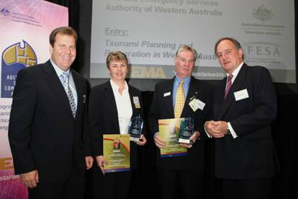
- The recognition by the emergency management community and the spatial industry through the Australian Safer Communities Award and Asia Pacific Spatial Excellence Award in 2007,
- An evidence base to underpin tsunami planning and preparation supported by validation, and
- An awareness of tsunami science for the emergency management community and the public.

The significance is:

- GA has influenced the tsunami emergency management agenda nationally through the Attorney General’s Department and the AEMC Tsunami Working Group and internationally through, for example, the IOC/IOTWS Tsunami Risk Assessment Guidelines.
- GA has been engaged by partners willing to support the development of a storm surge impact modelling capability based on the success of the tsunami program. This is now incorporated in the work program for my project for the next two years and beyond.

PART 2 – YOUR PERFORMANCE AT THE NEXT LEVEL
Provide evidence of your key achievements and their impact against each of the six criteria below, clearly demonstrating that your performance is equivalent to that expected at the next Level and has had visible, value adding impact. Ensure you provide key dates that demonstrate your claims over the sustained period.

Achievement of Outputs/Results
Application of skills, knowledge, expertise; Contribution to team achievements; Record of achievement of results/outputs of value to GA project/work area.
My work in GA since my commencement in Nov 2005 has developed a tsunami risk modelling methodology that has changed the understanding of tsunami hazard and impact to Australian communities. I have done this by establishing solid and long term partnerships with Australian and State Governments with the aim of providing an evidence base to underpin tsunami planning and preparation activities by emergency managers.

The outcomes of these partnerships are:
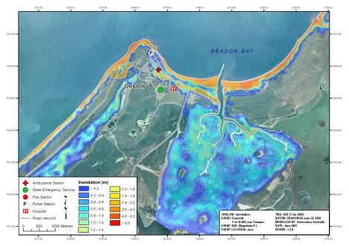
- emergency managers and decision makers in WA now understand which communities are most at risk (2006-09). These are not the north west Shelf communities as expected, but some of the densely populated communities in the south,
- the Australian emergency management community understands the tsunami modelling methodology and how it was implemented by the Fire and Emergency Services Authority, Western Australia (FESA). This was a result of a joint publication with FESA in the Australian Journal of Emergency Management 2008,
- tsunami planning and preparation initiatives of the Jurisdictions is improved through:
- the successful roll out and uptake of a national awareness presentation (called ITEM) that described the nature of the tsunami hazard (2007-09). I was the key GA representative at these presentations that were led by AGD,
- the development of prioritisation tools to select communities for detailed assessment (hazard maps, 2008-09). This described the role of the continental shelf and reefs on propagation,
- the provision of detailed inundation results to three Jurisdictions (2008-09). This has supported decision making to manage tsunami risk.
- emergency managers in NSW are now aware of the potential for impact due to submarine mass failure off the continental shelf (2006). I worked with the PMD crew of the GA slope survey to estimate the potential inundation,

- the Australian public are informed of the tsunami modelling methodology and how GA has partnered with emergency managers in understanding tsunami risk, see www.ga.gov.au/hazards/tsunami/reports.jsp.
I have achieved these outcomes by
- working with a team of modellers, software engineers, spatial analysts, marine scientists, engineers and geophysicists across GEMD and PMD,
- working with emergency managers, planners and data providers from the Jurisdictions from 2006-09, and
- applying my numerical modelling and applied mathematics skills, knowledge and expertise as well as strong leadership, management and client interaction skills.

Leadership
Strategic perspective and contribution; Leadership in specialist area; Leadership of People.
I have played a key leadership role in the development and delivery of tsunami impact and risk information to Australian and State Governments. I have been the key liaison between GA and emergency managers in producing outputs that have met client’s requirements. In particular,

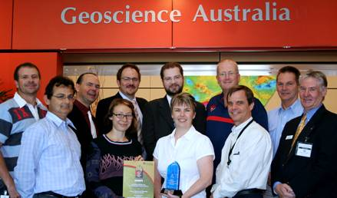
- I have been instrumental in aligning all aspects of the GA tsunami modelling activity with stakeholder requirements. The developed methodology met the needs of emergency managers and at the same time ensured that the science followed best practice (2006-09),
- I assumed situational leadership of the modelling team, data providers and client liaison. The activity ran smoothly and delivered on time every year (from 2006 to 2009), and
- I identified and followed up on QA issues that emerged from the evolving modelling methodology and ultimately put in place a documented and effective QA process (2006-09).

The evidence includes:
- A validated tsunami modelling methodology that has met and is guided by real world requirements,
- A high performing team that has delivered desired results to stakeholders since 2006, and
- An improved national understanding of tsunami hazard and impact that was achieved by influencing AGD to support GA to undertake key capacity building activities.

Since Jan 2009, my role in the tsunami modelling activity changed to one of overall project leadership. To continue achieving the tsunami modelling outcomes, I successfully transferred elements of this liaison role to others in the team. In particular I have mentored staff in taking the lead on specific client relationships. This has resulted in them now developing client liaison skills and delivering products of value to GA.

Management
Managing self; Managing others; Management of project/work area/activity; Communication, liaison, negotiation and influencing skills.
I have been responsible for the delivery of tsunami modelling outputs to a range of stakeholders. This has required a broad range of management skills. Examples are:
- brought together a team across GA to achieve the tsunami modelling projects. The team included experts in bathymetry and submarine landslide characteristics from PMD and topography from GEMD (2006-09). This has created a dynamic team focused on client delivery and best practice science.
- initiated and developed processes in consultation with the team to improve the modelling methodology. This has enhanced the transparency, accountability and effectiveness of the tsunami modelling process.
- promoted the model outputs to stakeholders through the development of award submissions. This has influenced the emergency management and spatial science community.
- recruited two level four computational modellers (08) and secured volunteer (09),
- managed and supervised two level four modellers (08) and a level six modeller (09).
Since Jan 2009, I have been responsible for the delivery of all project outputs. The range of management skills exercised are:
- managed and supervised one level six, three level fives and one level four scientist in a range of different areas of expertise,
- managed the budget through a period of uncertainty,
- developed staff by focusing on training opportunities when underspend was made available,
- managed availability of IT and computational resources, and
- recruited two level four scientists in the wake of staffing losses and absences.

Client Interaction
Identifying client needs; Meeting client needs; Developing new ventures/projects/products.
The tsunami modelling activity is a high profile project involving clients and stakeholders nationally and internationally. Clients include AGD, State and Territory Governments, academia and international organisations with stakeholders spanning data providers to land use planners. My role has been to ensure that science is translated to these users and in turn that their requirements are incorporated in the continued development of the tsunami modelling methodology. Key impacts are:
- Evidence base to underpin tsunami planning and preparation,

- Awareness of tsunami science for emergency managers and stakeholders,
- Understanding of the importance of elevation data that has provided evidence to support further data acquisition and analysis in WA, and
- Establishment of a MoU with Department for Planning and Infrastructure (DPI) for storm surge modelling in WA.
The latter is a key example of my strong client interaction skills as this partnership has resulted through stakeholder workshops conducted by FESA. I successfully demonstrated the modelling expertise and client delivery skills of GA and engaged with DPI who could benefit from these skills in an emerging and important area of climate change.
I have accomplished these impacts through
- developing relationships with clients through the AEMC’s Tsunami Working Group,
- being the key GA representative in ITEM and FESA workshops, and
- presenting to various visitors to GA relating to tsunami risk modelling (such as the IOC, Philippines, South African and Omani government delegations).
An example of the strength of our client relationships is exemplified when the team discovered a modelling issue that affected the recent delivery of impact assessments to FESA. I clearly described the issue and the impact on results to FESA that they accepted in light of the understanding that the underlying methodology has evolved since 2005.

Corporate Contribution
Corporate awareness; Involvement in GA/RET/APS/professional arena activities; Sharing expertise; Corporate information management.
- Represented GA and Australia by presenting to the International Workshop for Natural Disasters and Emergency Management in Beijing in Sep 2007.
- Supported GA’s educational initiatives by regularly presenting to school groups and identifying opportunities to support emerging policies for emergency management as well as highlight the role of numerical modelling in geoscience.
- Supported the ANAO performance review with the FESA project selected as a natural hazard risk modelling example.

Learning and Development
Development of Professional/Technical skills, knowledge, expertise; Development of self in line with GA key work values (Leadership, Management, Client Interaction, Corporate Contribution); Development of others.
Important developments include
- Completing Geoplus 2008 honed my corporate awareness and management/leadership skills.
- Applying and developing ANUGA improved my modelling skills, and
- Presenting at the International Workshop on Natural Disasters and Emergency Management increased my understanding of regional developments in managing natural hazard risk.

Applicant's Signature: |  | Date: | / /

CHECKLIST BEFORE SCANNING AND UPLOADING TO THE GA ONLINE APPLICATION SYSTEM

Is your name in the footer on each page of your application?
Is your application printed double sided?
Is your application claims section no more than 3 pages in length?
Have you included your Nominated Manager’s reference?
Are all of the papers appropriately signed and dated?

REFERENCE: NOMINATED MANAGER
LEVEL ADVANCEMENT

REFERENCE: HIGHER LEVEL

Applicant’s Details
Name: |  | Phone:

Nominated Manager’s Details
Name: |  |  | Phone:
Time period on which reference is based:

Referee to Complete
Rate the applicant’s performance against all six criteria in terms of the standard expected for the higher Level. It is recommended that you seek input from others who are familiar with the applicant’s work before completing your report.

Performance Ratings (H = High, E = Effective, U = Unsatisfactory)
Performance Criteria | Performance Rating
1. Achievement of Results/Outputs
Application of skills, knowledge, expertise; Contribution to team achievements; Record of achievement of results/outputs of value to GA project/work area/clients
Comments:

2. Leadership
Strategic perspective and contribution; Leadership in specialist area; Leadership of people
Comments:

3. Management
Managing self; Managing others; Management of project/work area/activity; Communication, liaison, negotiation and influencing skills
Comments:

4. Client Interaction
Identifying client needs; Meeting client needs; Developing new ventures/projects/products
Comments:

5. Corporate Contribution
Corporate awareness; Involvement in GA/RET/APS/professional arena activities; Sharing expertise; Corporate information management
Comments:

6. Learning and Development
Development of Professional/Technical skills, knowledge, expertise; Development of self in line with GA key work values (Leadership, Management, Client Interaction, Corporate Contribution); Development of others
Comments:

Overall Performance Rating

Provide specific evidence and impact of the applicant’s performance at the higher level.

The applicant’s work responsibilities and performance have been at the Level for which they are applying and has been demonstrated over a sustained period (Sustained period means 2-3 years for Band 3; 1-2 years for Bands 1 and 2). o Y o N
Nominated Manager’s Signature: |  | Date: | / /
Printed Name:

REFERENCE: REFEREE*
LEVEL ADVANCEMENT

REFEREE REPORT

Applicant’s Details
Name: | Jane Sexton | Phone: | x9841

Referee’s Details
Name: | Ole Nielsen |  | Phone: | x9048
Position: | Senior Computational Scientist/Team Leader
Time period on which reference is based: |  | 2005 to present

* If using a referee other than your Nominated Manager, provide an explanation.
Ole was my manager from 2005 to June 2008. We are still working closely together.

Referee to Complete
Rate the applicant’s performance against the following six criteria in terms of the standard expected for the higher Level (i.e. the level that the applicant is applying for).

Performance Ratings (H = High, E = Effective, U = Unsatisfactory, N = Not applicable/Unable to Assess)
Performance Criteria | Performance Rating
1. Achievement of Results/Outputs
Application of skills, knowledge, expertise; Contribution to team achievements; Record of achievement of results/outputs of value to GA project/work area/clients
Comments:
Jane has been vital for the success of Geoscience Australia’s tsunami risk modelling program in her role as scientific leader and manager.

Jane was employed in late 2005 to manage and develop a partnership with state emergency services to better understand tsunami risk to coastal communities. She was also instrumental in the development of Geoscience Australia’s Tsunami Risk Modelling Methodology which underpins this and subsequent partnerships both scientifically and technically.

Jane’s achievements are considerable:

- A solid and long term partnership with WA Fire and Emergency Services that has changed the understanding of Tsunami Risk to the WA communities.
- This partnership has been recognised by the awards, articles and GDAL presentation listed in her application..
- Emergency managers and decision makers in WA now understand that the communities most at risk are not the ones in the north closest to the tsunami sources off Indonesia but some of the dense communities in the south that are close to the shore and situated in coastal zones that tend to amplify the tsunami waves
- Development and pioneering of the tsunami modelling methodology which has been published and which has led to funding of other new projects such as the EMA’s Near Shore Tsunami Hazard Map and Tsunami Impact Modelling for Qld, NSW and Tasmania.
- The new venture into Storm Surge modelling with WA DPI is a direct result of Janes stakeholder work and her intimate knowledge of the science behind the models.

2. Leadership
Strategic perspective and contribution; Leadership in specialist area; Leadership of people
Comments:

3. Management
Managing self; Managing others; Management of project/work area/activity; Communication, liaison, negotiation and influencing skills
Comments:
Jane took on direct day-to-day management of the tsunami modelling activity and the stakeholder management when she started in 2005 and the success of this activity is in no small part due to Jane’s ability to manage complex processes and relationships. Jane has also been project manager for some years and, more recently, she has taken over the Natural Hazard Impact Project as project leader.
Jane possess a rare ability to combine profound scientific knowledge and strategic thinking about applications with excellent people skills which is why she has been so successful over the years.

As project manager for the Georisk project this year, Jane has achieved
- Scoping, oversight and timely delivery of
  - Nearshore Tsunami Hazard Map (funded by EMA) – Traffic Light Report
  - Tsunami impact modelling for four East Australian Communities
  - Tsunami impact models for Fire & Emergency Services Australia
- Development of new Storm Surge Modelling Activity to commence this financial year, funded by WA Department of Planning and Infrastructure and leveraging from synergies with Department of Climate Change funded projects.
- The restructuring and formation of new Natural Hazard Impacts Project focused on Modelling and Applications both in Australia and Regionally.

4. Client Interaction
Identifying client needs; Meeting client needs; Developing new ventures/projects/products
Comments:
Jane’s has been and is the point of contact for our clients whether it is state government emergency services, Attourney General’s or high level steering committees such as the ATWG. In all contexts, Jane has acted with integrity, sensitivity and assertiveness to build long term partnerships build on mutual trust.

5. Corporate Contribution
Corporate awareness; Involvement in GA/RET/APS/professional arena activities; Sharing expertise; Corporate information management
Comments:

Jane is a very conscientious corporate citizen and the highlights listed in her application serve as good examples of her care for the organisation’s standing.

6. Learning and Development
Development of Professional/Technical skills, knowledge, expertise; Development of self in line with GA key work values (Leadership, Management, Client Interaction, Corporate Contribution); Development of others
Comments:

As stated in the application, Jane continually develops and learns as needed. Notable examples are her rapid assimilation of the ANUGA model, learning the science behind tsunami, organisational skills and Geoplus.

Overall Performance Rating

Specific comments about the applicant’s performance.
As stated above Jane is a role model for a leader in a science agency due to her exceptional interpersonal skills, ability to juggle complex problems, strategic intuition and her solid scientific discipline.

Her successful application for merit promotion will be of the greatest value to Geoscience Australia.

Referee’s Signature: |  | Date: | / /
Printed Name:

